Email Spam and Non-Spam Classification
Design Document

Version 1.0



Group Id: F2002F5DD9
Supervisor Name :Muhammad Tayyab Waqar

Revision History
Date (dd/mm/yyyy) | Version | Description | Author
17/01/2021 | 1.0 | Email Spam and Non-Spam Classification Project categorizes email messages into two heads Spam and Non-spam using a Python based text classification technique. Furthermore, the project also includes accuracy, time and error rate calculation using suitable algorithms on an Email Dataset along with algorithms comparison to identify the best suitable model for the use case. | MC190402102

Table of Contents

- Introduction of Design Document
- Entity Relationship Diagram (ERD)
- Sequence Diagrams
- Architecture Design Diagram
- Class Diagram
- Database Design
- Interface Design
- Test Cases

- Introduction of Design Document
This software design document describes the architecture and system design of “Email Spam and Non-Spam Classification Project”, an AI based software agent that can be used to classify spam vs non-spam on email clients. This document will also illustrate the complete declaration for the development of system.

Software design is a process by which the Email Spam and Non-Spam Classification application’s requirements are translated into a representation of its components, interfaces, and data necessary for the implementation phase. This SDD shows how the application will be structured to satisfy the requirements.

- Entity Relationship Diagram (ERD)
An Entity Relationship (ER) Diagram is a type of flowchart that illustrates how “entities” such as people, objects or concepts relate to each other within a system. ER Diagrams are most often used to design or debug relational databases in the fields of software engineering, business information systems, education and research. Also known as ERDs or ER Models, they use a defined set of symbols such as rectangles, diamonds, ovals and connecting lines to depict the interconnectedness of entities, relationships and their attributes. They mirror grammatical structure, with entities as nouns and relationships as verbs.

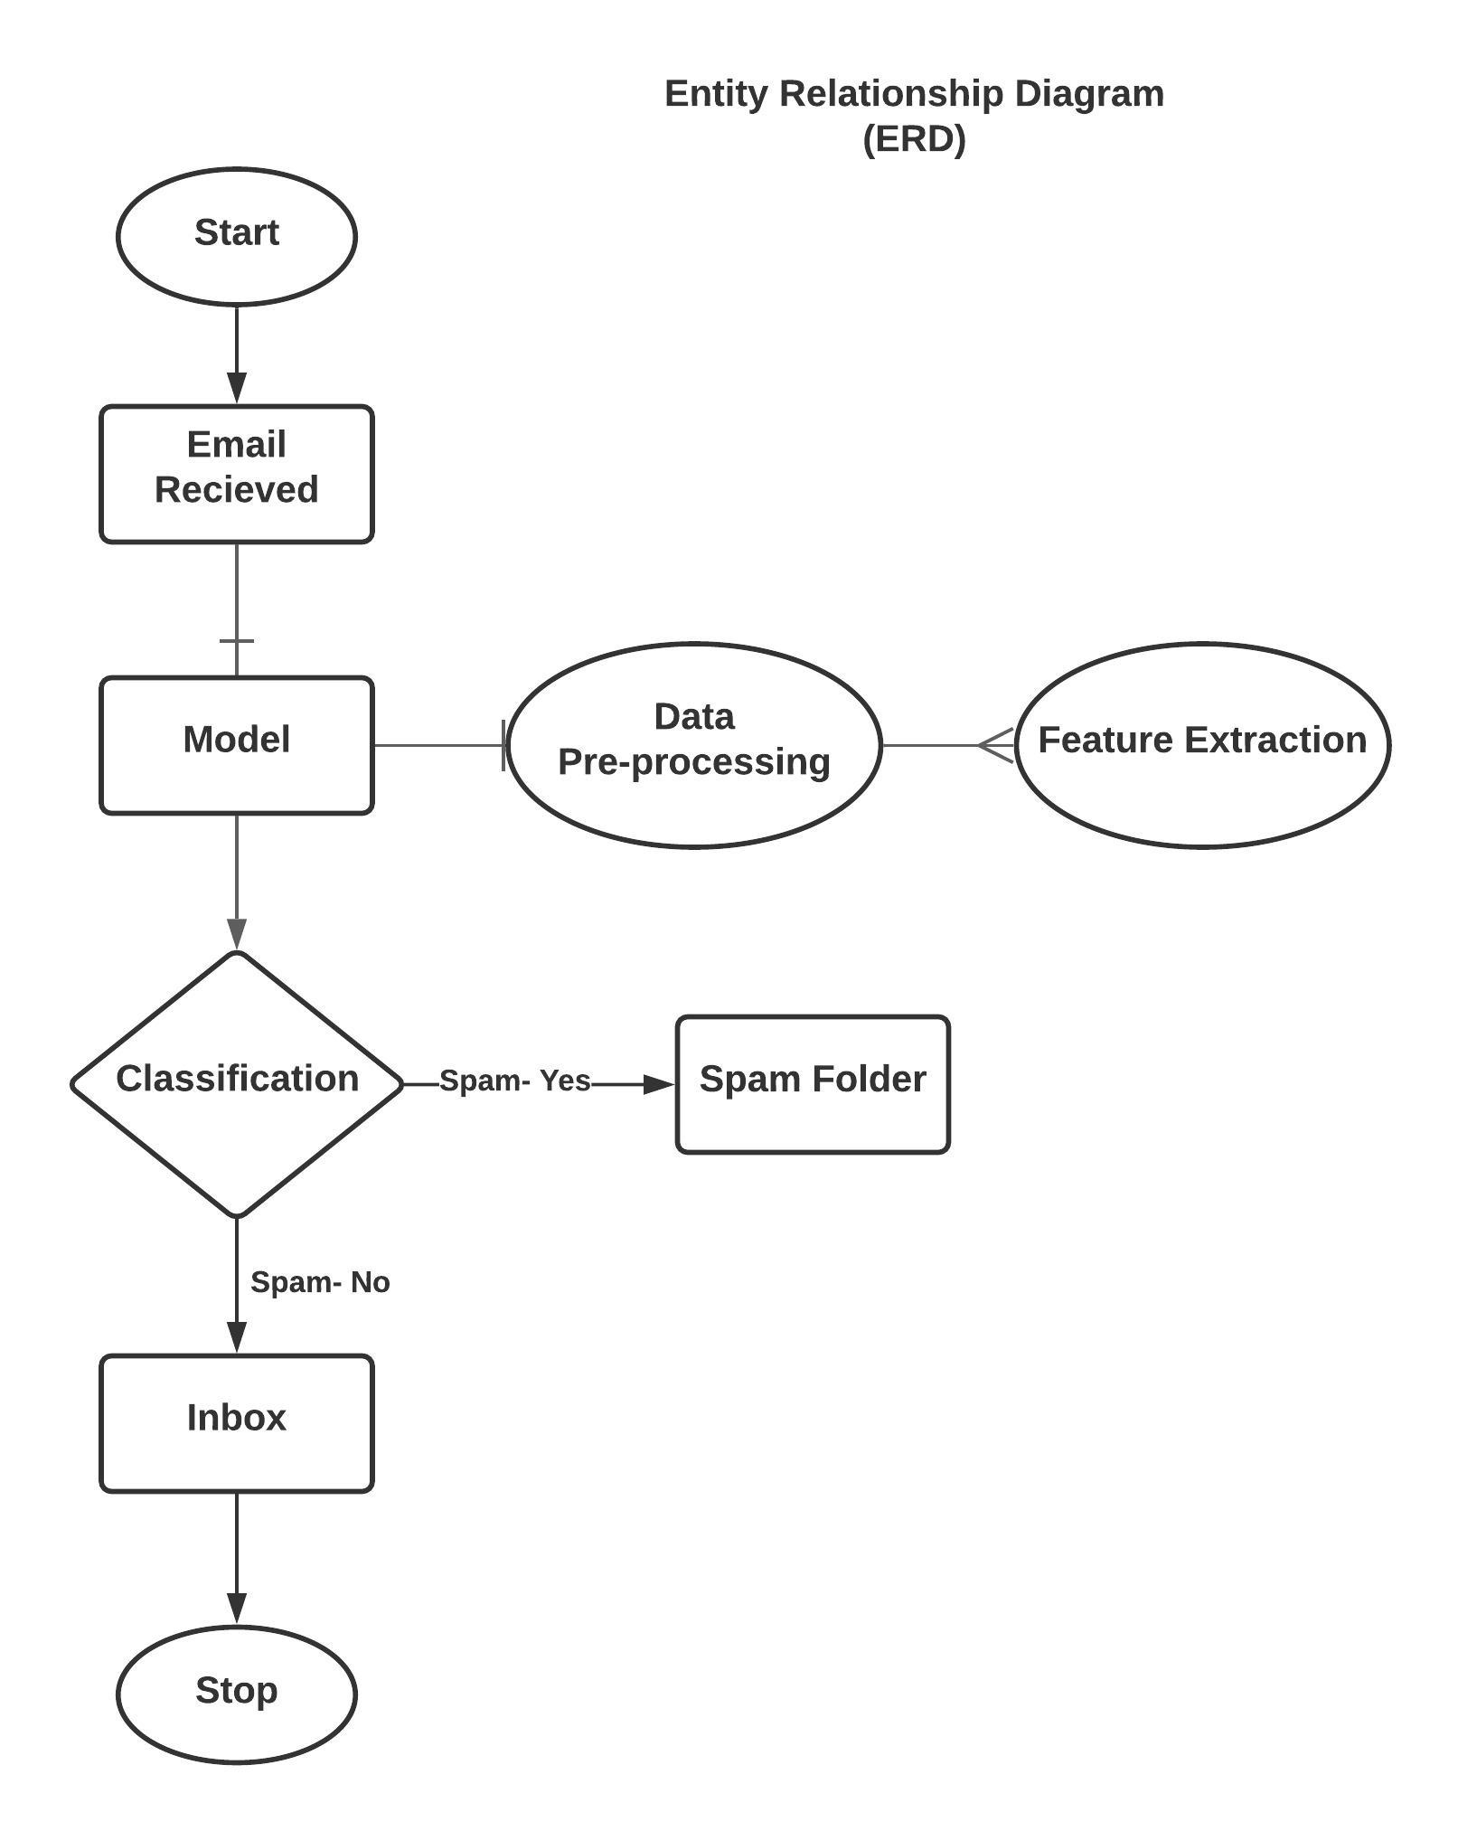

- Sequence Diagrams (To be developed using Rational Rose or any other drawing software of your choice)

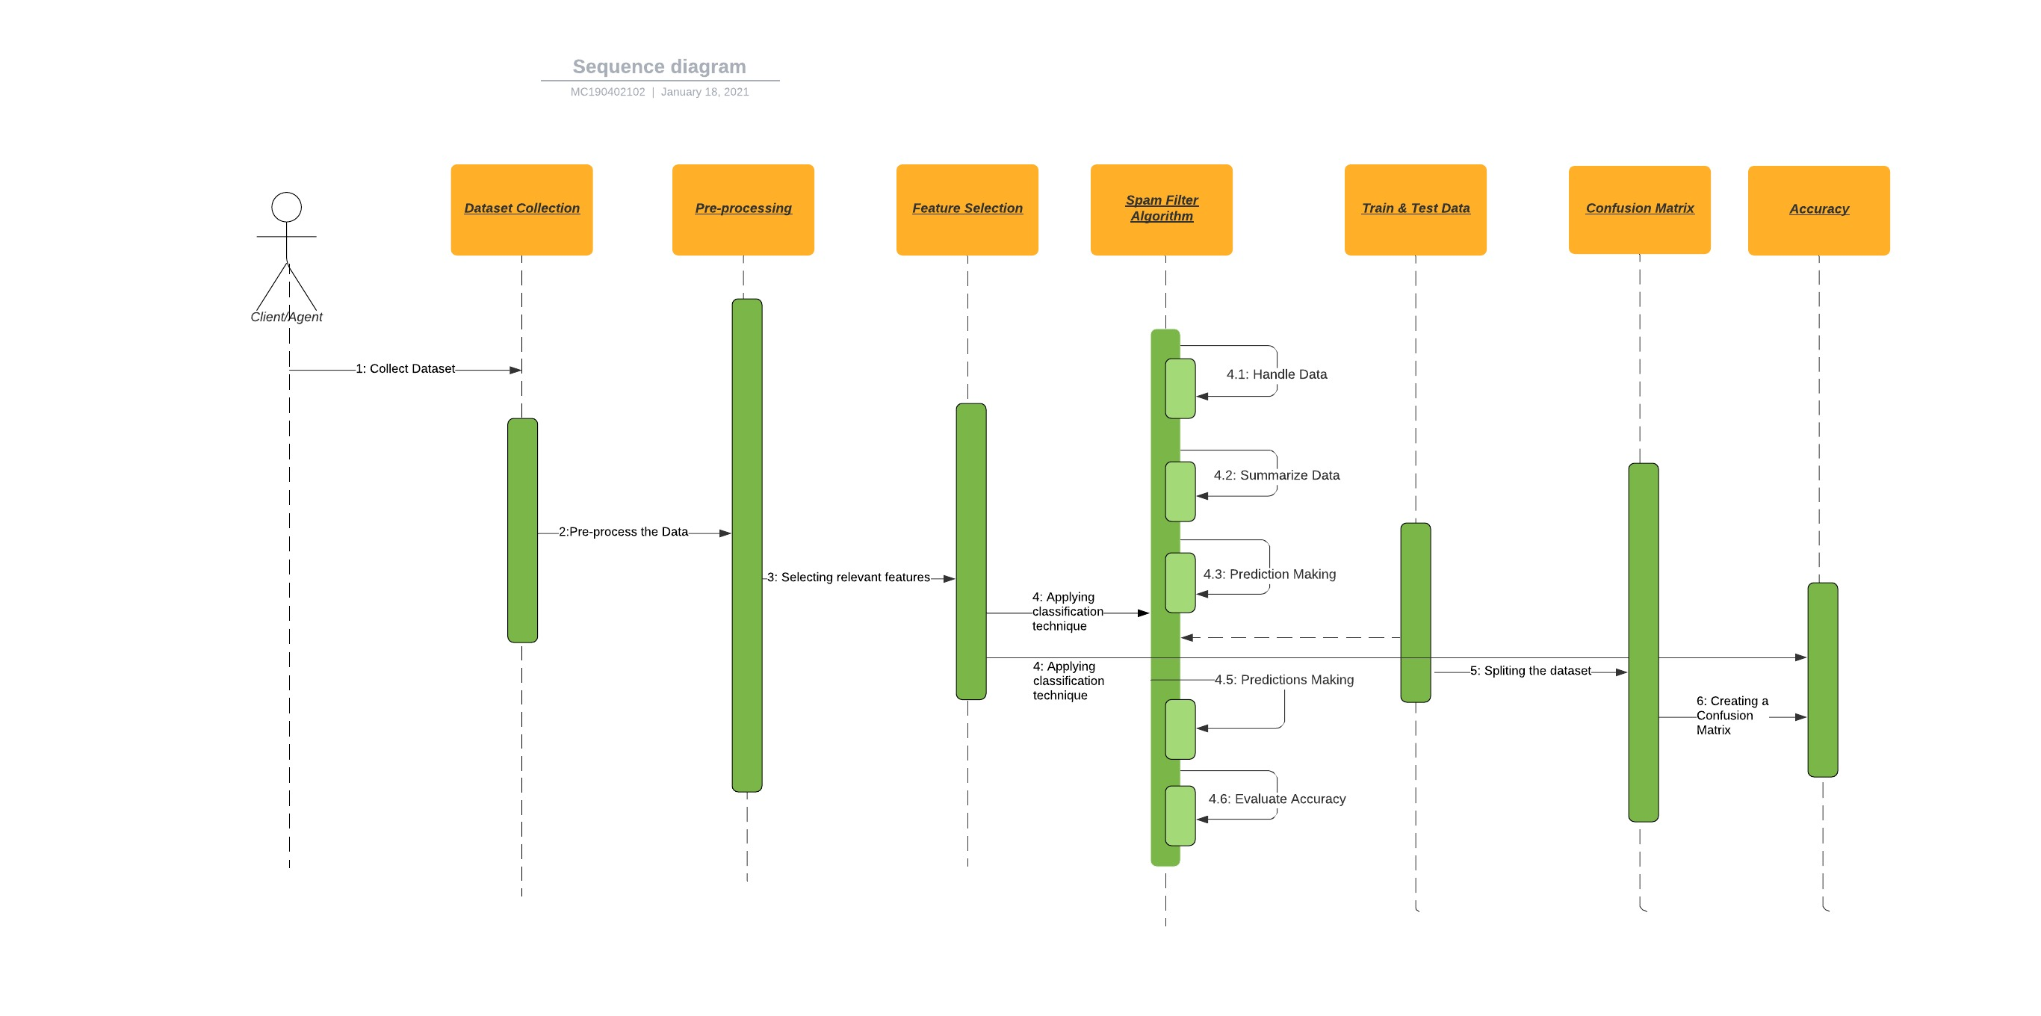

- Architecture Design Diagram
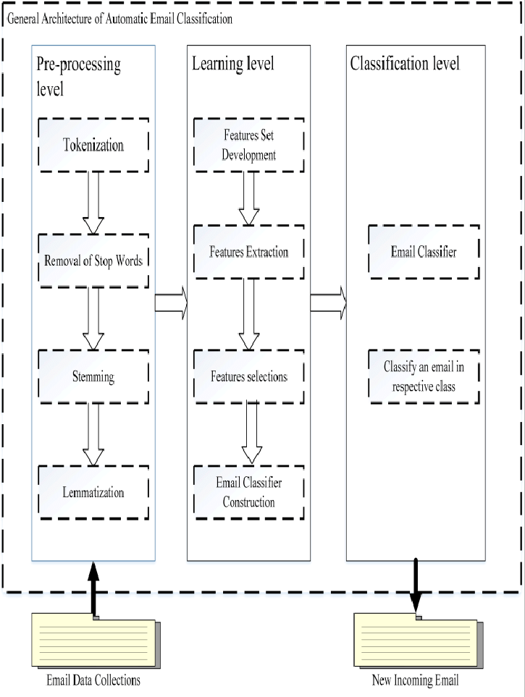

- Class Diagram

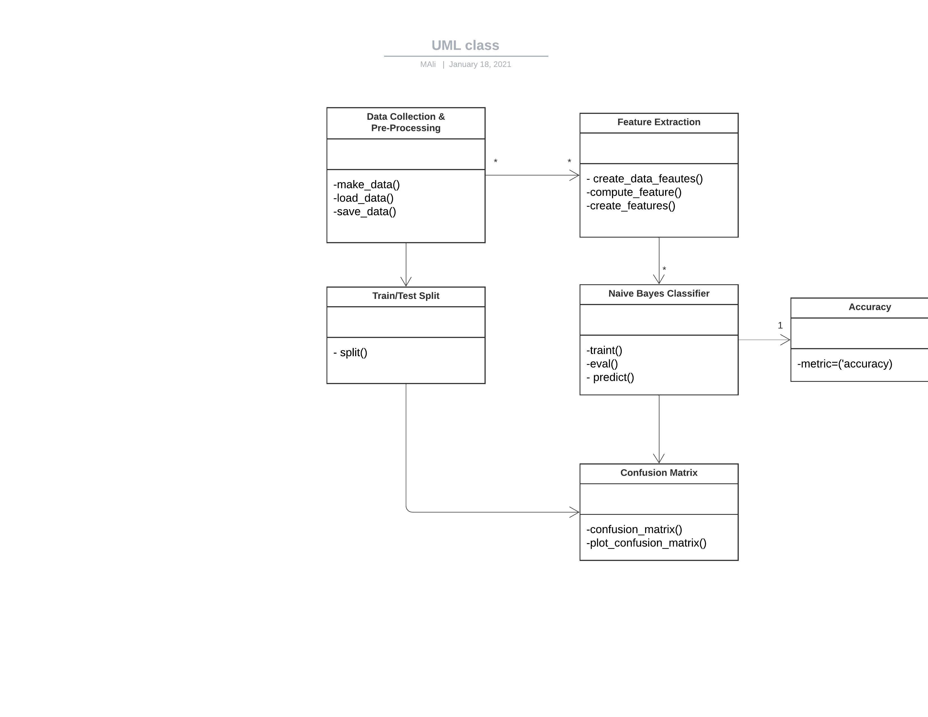

- Database Design

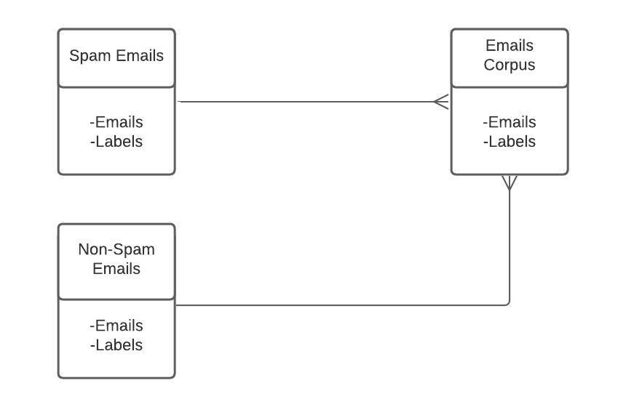

- Interface Design
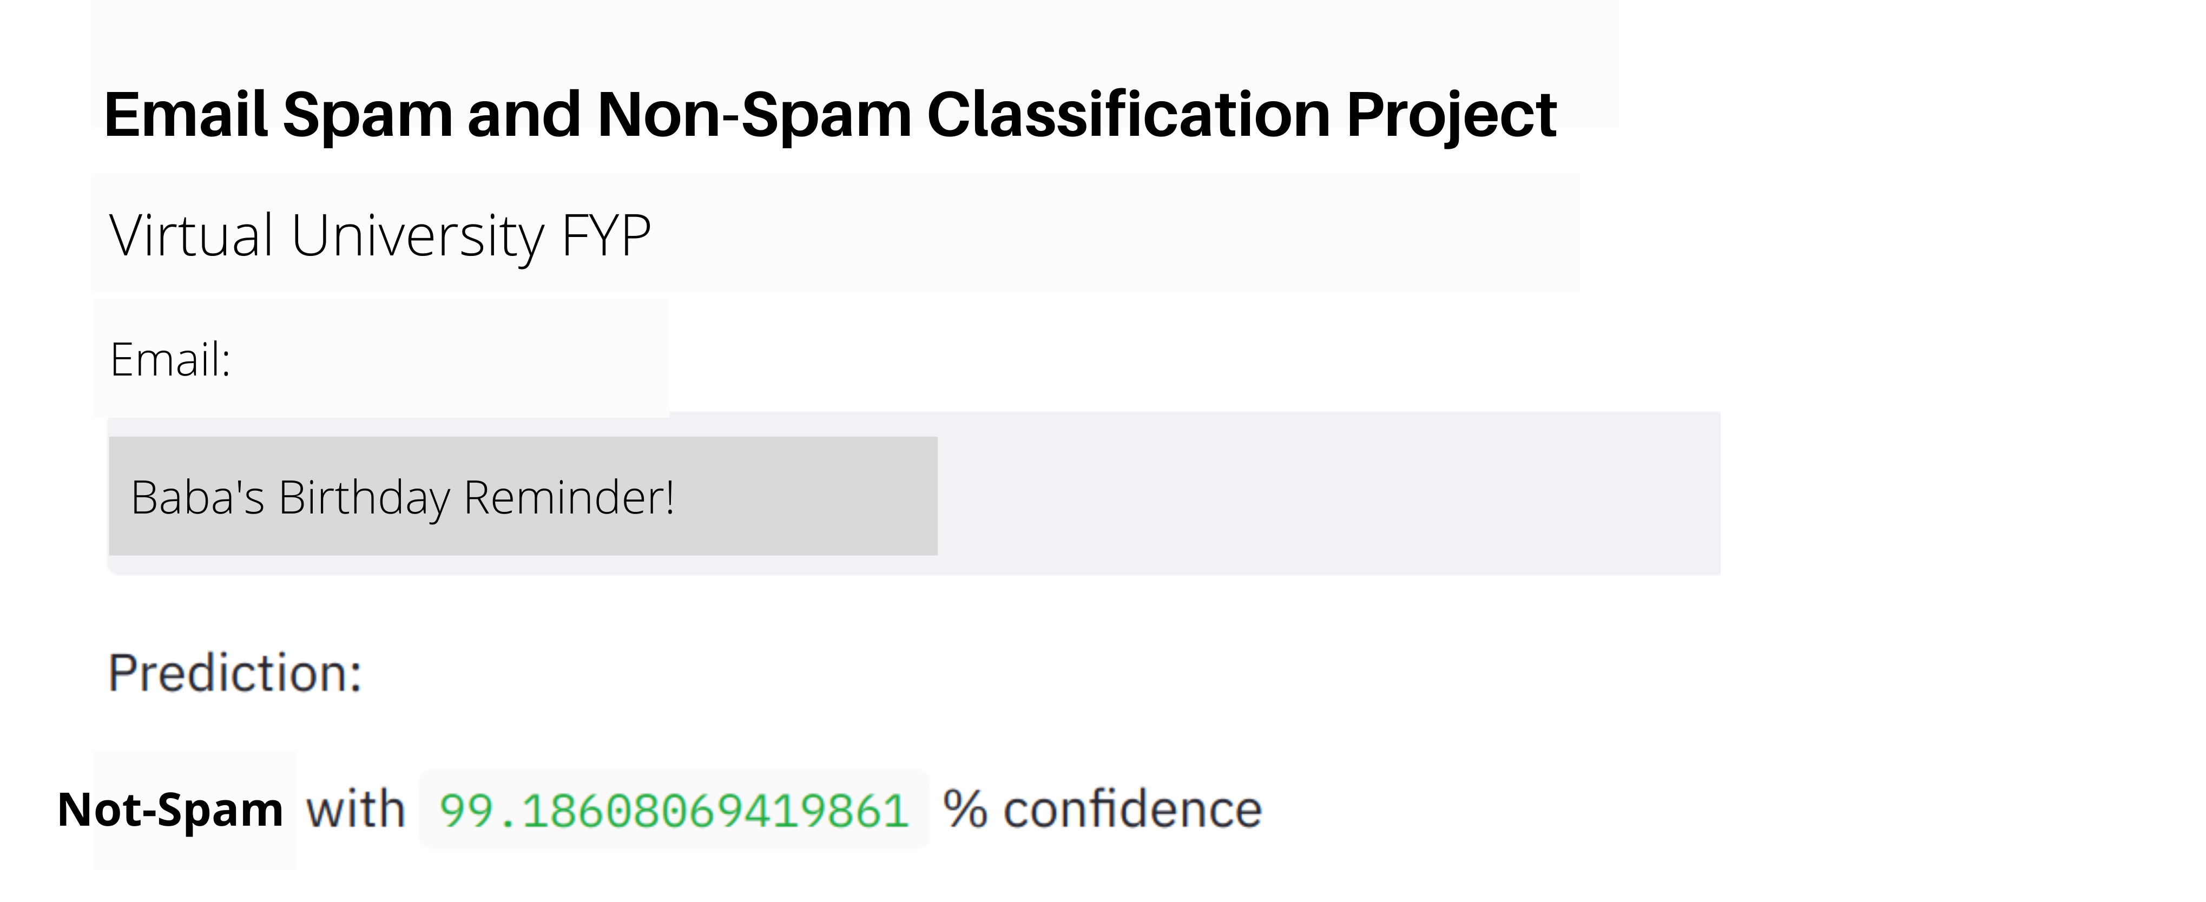
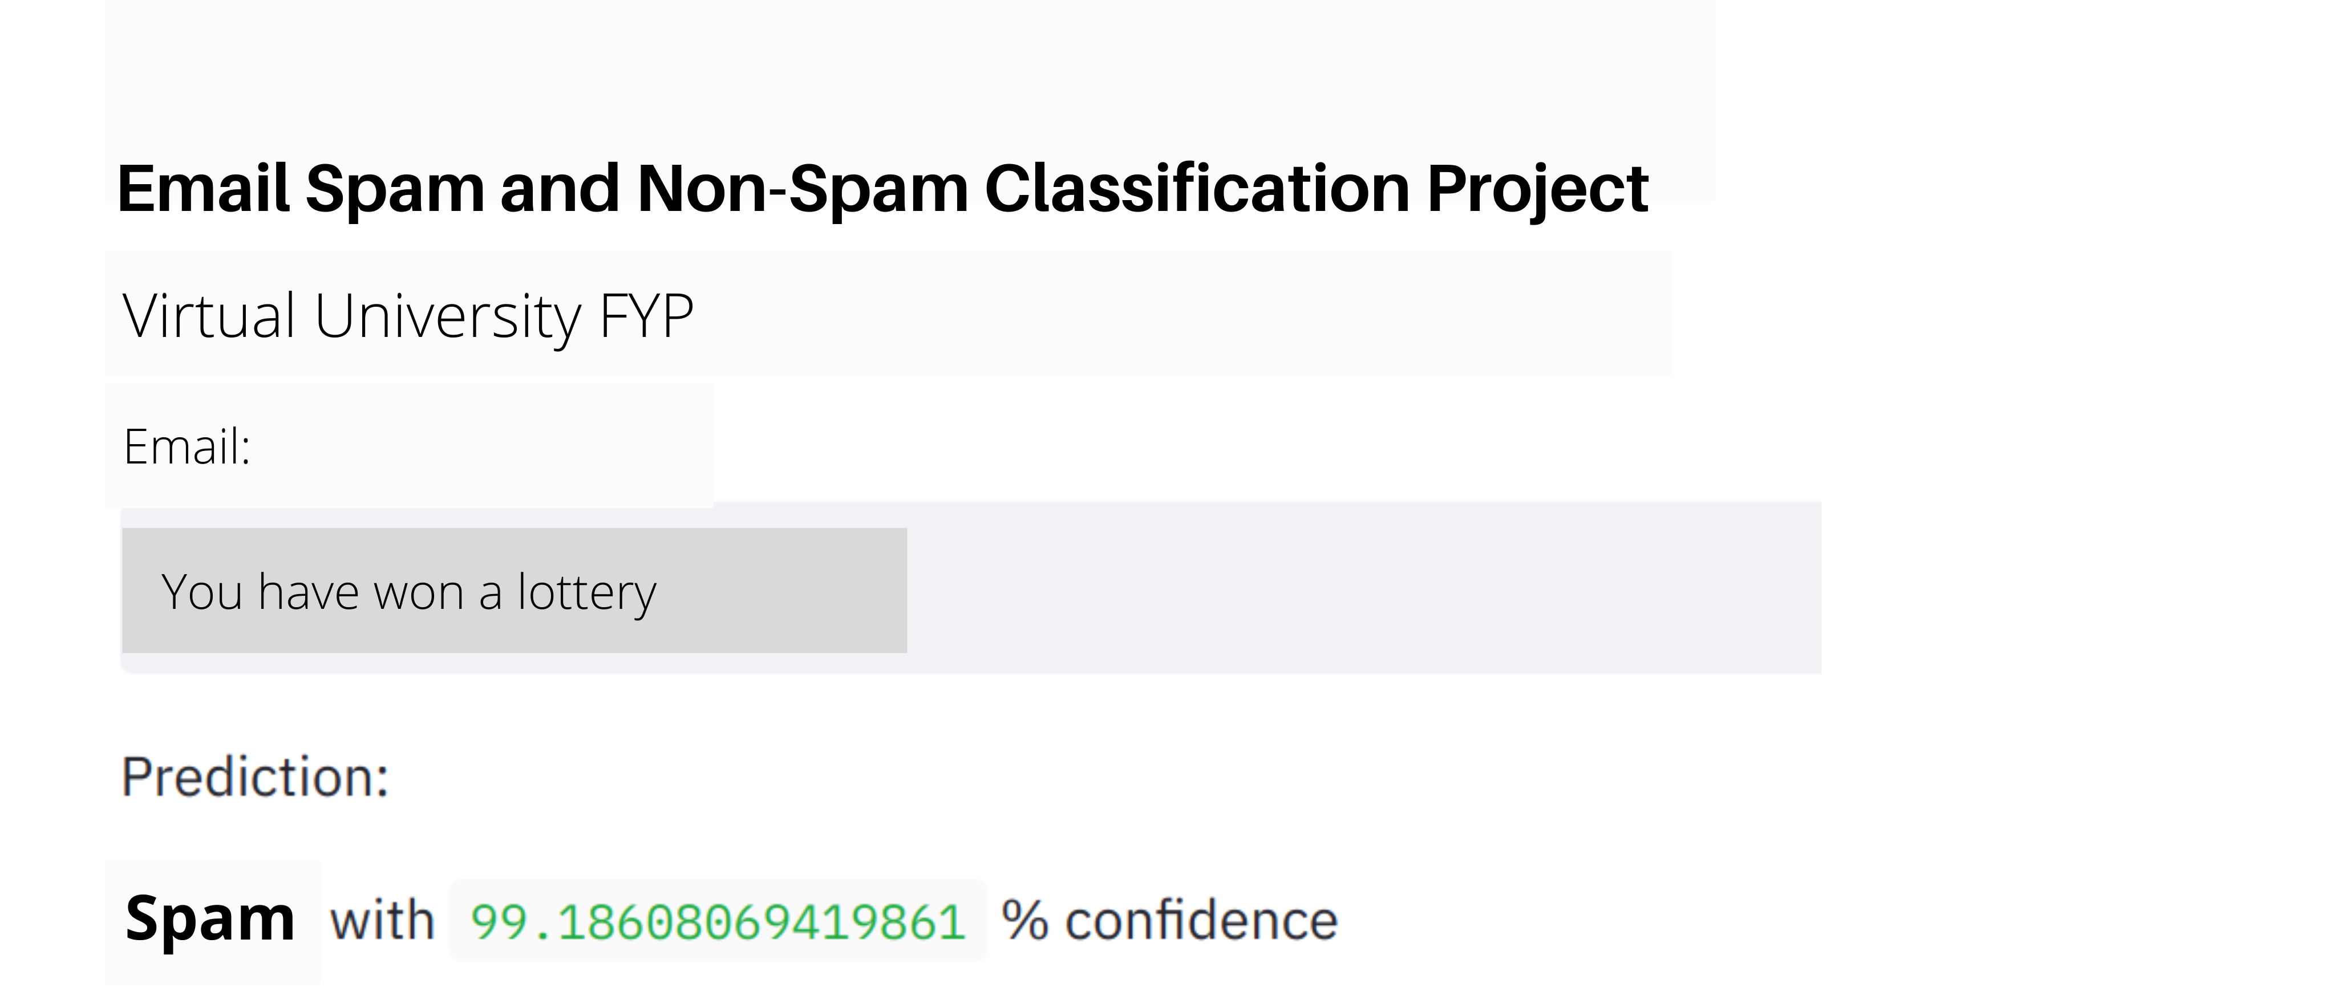
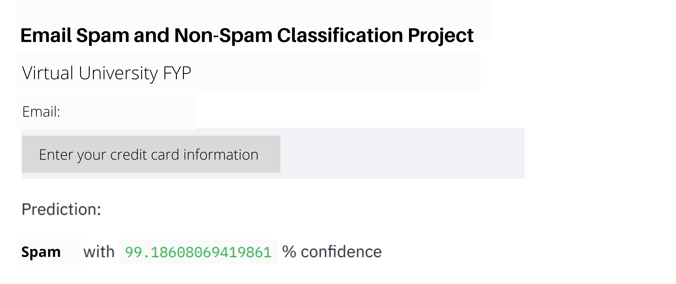

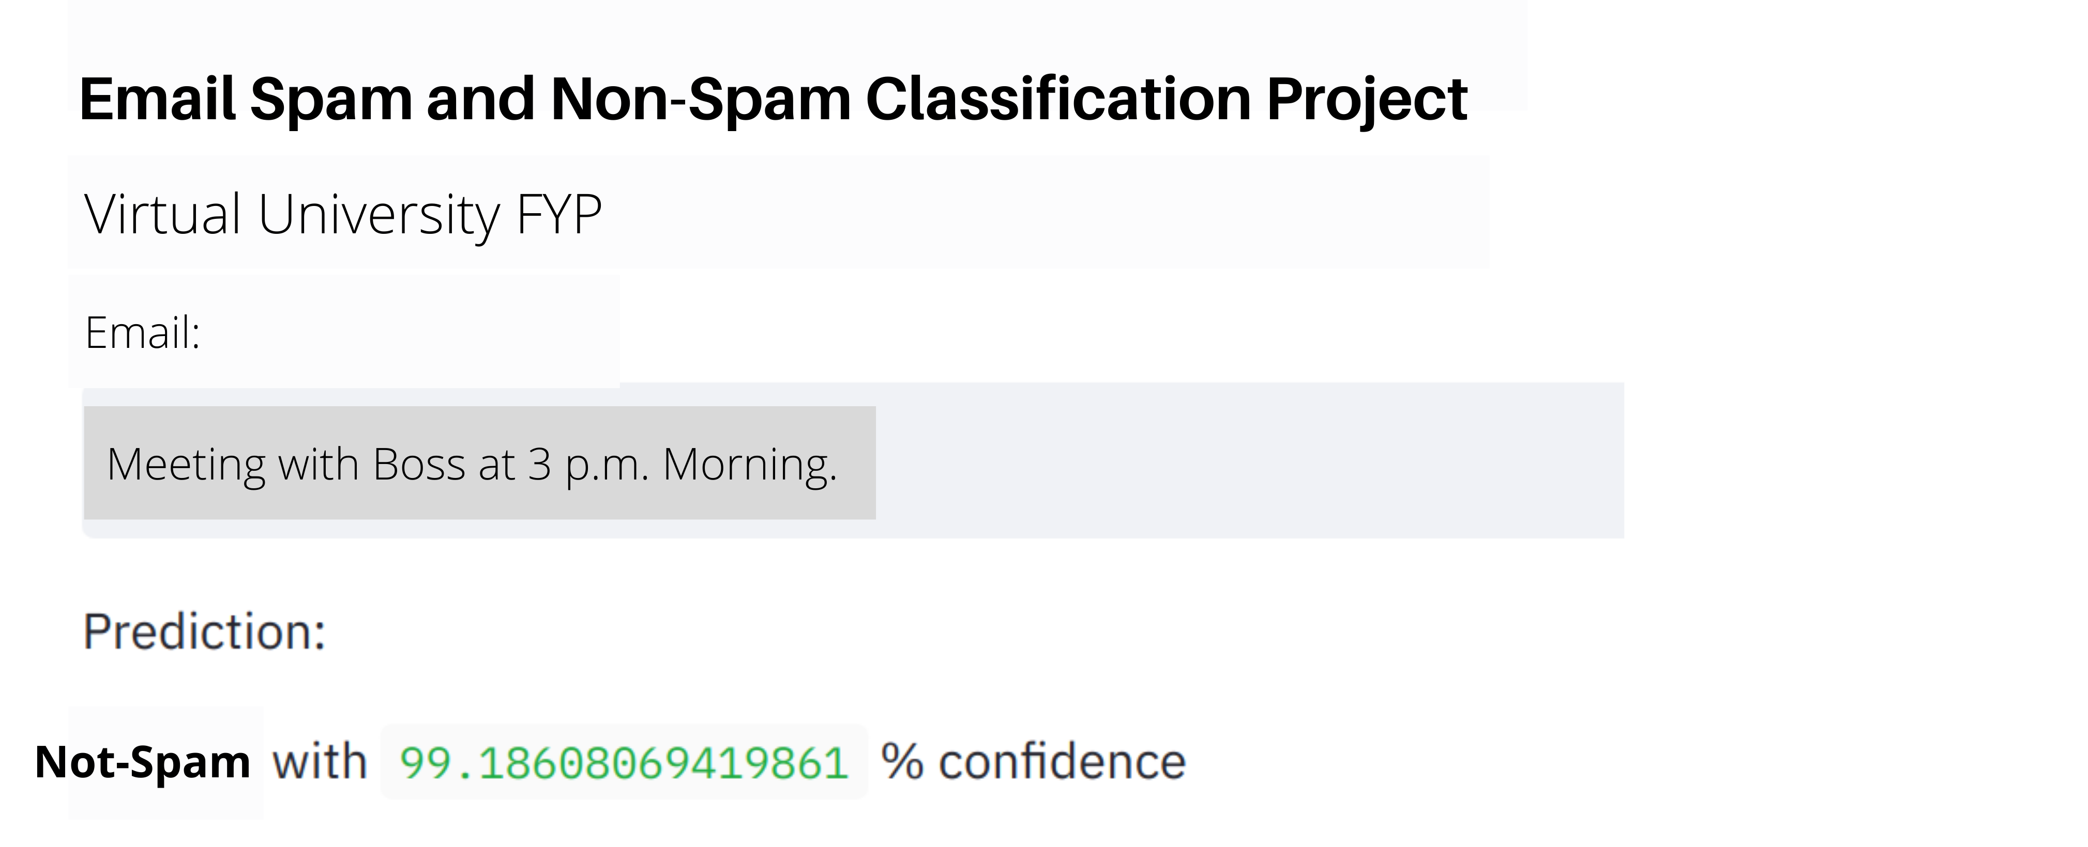

- Test Cases

Test Scenarios 1:

TEST CASE SCENARIO
Test Case No. | TC-1
Test Case Name | Data Collection
System | Email Spam and Non-Spam Classification
Precondition | There must be a dataset available containing both spam and non-spam messages.
Action | Expected Results
- Collecting Dataset | - The dataset will be loaded into the system.
Post-Condition | The system will have the dataset as an unprocessed data.
Result | Pass
Tested by | MC190402102

Test Scenarios 2:

TEST CASE SCENARIO
Test Case No. | TC-2
Test Case Name | Pre-processing
System | Email Spam and Non-Spam Classification
Precondition | Dataset must be provided for pre-processing
Action | Expected Results
- Pre-processing the Data | - The data will be in pre-processed form.
Post-Condition | The system will have the email message in the pre-processed form, ready to be forwarded into feature extraction use case.
Result | Pass
Tested by | MC190402102

Test Scenarios 3:

TEST CASE SCENARIO
Test Case No. | TC-3
Test Case Name | Feature Selection
System | Email Spam and Non-Spam Classification
Action | Expected Results
- Selecting relevant features | - Relevant features will be selected from the pre-processed dataset.
Precondition | Dataset must be of pre-processed form.
Post-Condition | The spam filter algorithm will be ready to have extracted features to be used in classifying spam and non-spam emails.
Result | Pass
Tested by | MC190402102

Test Scenarios 4:

TEST CASE SCENARIO
Test Case No. | TC-4
Test Case Name | Spam Filtering Algorithm
System | Email Spam and Non-Spam Classification
Action | Expected Results
- Applying classification technique | - Classification technique will be applied on the selected features.
Precondition | The selected features must includes words that convey meaning and should not include words that are meaning-less like articles.
Post-Condition | The algorithm will provide a single result of whether the message is spam or non-spam.
Result | Pass
Tested by | MC190402102

Test Scenarios 4.1:

TEST CASE SCENARIO
Test Case No. | TC-4.1
Test Case Name | Handle Data
System | Email Spam and Non-Spam Classification
Action | Expected Results
- Splitting the dataset | - Splitting the dataset into training and test datasets.
Precondition | The dataset must be available for loading the data into algorithm.
Post-Condition | The algorithm will have the dataset loaded into it.
Result | Pass
Tested by | MC190402102

Test Scenarios 4.2:

TEST CASE SCENARIO
Test Case No. | TC-4.2
Test Case Name | Summarize Data
System | Email Spam and Non-Spam Classification
Action | Expected Results
- Summarizing Data | - Summarizing the properties in the training dataset
Precondition | The dataset must be loaded into algorithm.
Post-Condition | We will be able to calculate probabilities and make predictions
Result | Pass
Tested by | MC190402102

Test Scenarios 4.3:

TEST CASE SCENARIO
Test Case No. | TC-4.3
Test Case Name | Make a Prediction
System | Email Spam and Non-Spam Classification
Action | Expected Results
- Making a Prediction | - generate a single prediction.
Precondition | The dataset must be in a summarized form.
Post-Condition | We will get a single prediction.
Result | Pass
Tested by | MC190402102

Test Scenarios 4.4:

TEST CASE SCENARIO
Test Case No. | TC-4.4
Test Case Name | Make Predictions
System | Email Spam and Non-Spam Classification
Action | Expected Results
- Making Predictions | - Generate predictions given a test dataset and a summarized training dataset.
Precondition | The dataset must be available into two groups i.e. train and test datasets.
Post-Condition | We will get multiple prediction outputs
Result | Pass
Tested by | MC190402102

Test Scenarios 4.5:

TEST CASE SCENARIO
Test Case No. | TC-4.5
Test Case Name | Evaluate Accuracy
System | Email Spam and Non-Spam Classification
Action | Expected Results
- Evaluate Accuracy | - Evaluate the accuracy of predictions
Precondition | The algorithm must be generating predictions.
Post-Condition | We will get accuracy of predictions made for a test dataset as as the percentage correct out of all the predictions made.
Result | Pass
Tested by | MC190402102

Test Scenarios 5:

TEST CASE SCENARIO
Test Case No. | TC-5
Test Case Name | Train & Test Data
System | Email Spam and Non-Spam Classification
Action | Expected Results
Spliting the dataset | This use case splits data into 70% training & 30% testing data sets
Precondition | The algorithm must be generating predictions with fair accuracy.
Post-Condition | We will get 70:30 ratio based division of our dataset into train and test datasets respectively.
Result | Pass
Tested by | MC190402102

Test Scenarios 6:

TEST CASE SCENARIO
Test Case No. | TC-6
Test Case Name | Confusion Matrix
System | Email Spam and Non-Spam Classification
Action | Expected Results
- Creating a Confusion Matrix | - Creates a confusion matrix table
Precondition | The dataset must be divided into two parts train and test dataset and we also have predictions.
Post-Condition | The Confusion Matrix will be created for further analysis.
Result | Pass
Tested by | MC190402102

Test Scenarios 7:

TEST CASE SCENARIO
Test Case No. | TC-7
Test Case Name | Accuracy
System | Email Spam and Non-Spam Classification
Action | Expected Results
- Accuracy Measurement | - Model’s accuracy is measured
Precondition | The dataset must be divided into two parts train and test dataset and we also have a trained model.
Post-Condition | The accuracy will be generated for further optimization or deployment.
Result | Pass
Tested by | MC190402102

